Raspberry Pi 2.8-inch Screen Instruction

Contents

1. Intro .............................................................................................................. 2
2. Specifications ............................................................................................... 2
3. Pin definations .................................................................................................... 3
4. Construction .................................................................................................... 4
5. Quick Start .................................................................................................... 5

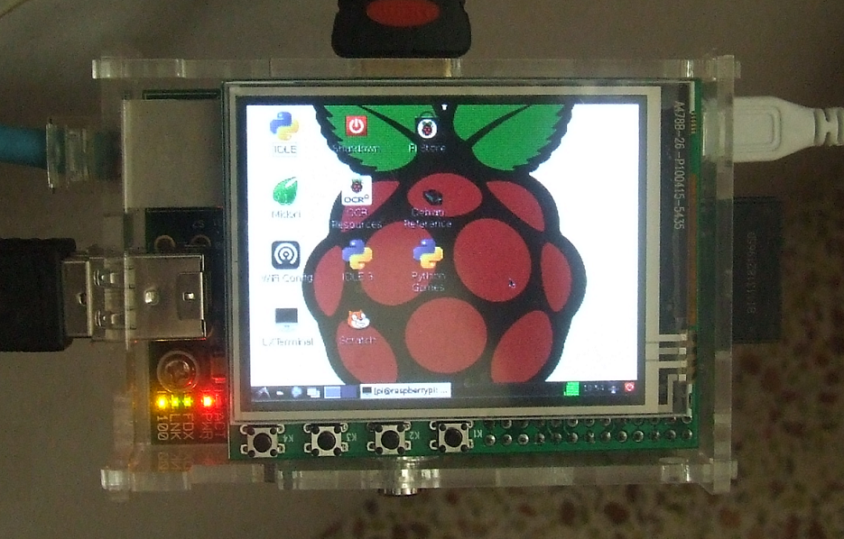

1. Intro
MZT280-PI-EXT LCD expansion module is specifically designed for the Raspberry Pi. By using the GPIO and SPI ports on the P1 port as the data transfer medium you will be able to connect the Raspberry Pi to the display. The LCD module’s CPLD display information based on data provided by the SPI port.

The module has the specifications below:
-  Easy to set up and use
-  320x240，16bit，65K color
-  2.8 inch resistive touch screen
-  Display uses SPI connection，with a 125MHZ top conversion rate
-  Touch screen uses SPI connection，with a 16MHZ top conversion rate
-  Integrated Power
-  The board comes with 4 push buttons and a infrared receiver（optional）,as well as a EEPROM memory module。
-  Open source Linux driver

2. Specifications
MZTX-PI-EXT LCD module was built with a high speed CPLD chip（EPM3032），a SPI port 4 wire resistive touch screen control chip （XPT2046），and a I2C port EEPROM memory storage unit（AT24C02）。
The I2C interface chip（AT24C02）’s address is：0xA0

3. Pin Definations

Raspberry Pi P1 port |  | MZT280-PI-EXT
 | 3V3 Power
 | 5V Power
 | GPIO-0(IIC SDA) | AT24C02 SDA Data Pin
 | 5V Power
 | GPIO-1(IIC SCL) | AT24C02 SCL Clock Pin
 | GND
 | GPIO-4 | XPT2046 IRQ Interrupt
 | GPIO-14
 | GND
 | GPIO-15 | LCD RST Display Reset
 | GPIO-17 | Infrared Data
 | GPIO-18(PWM) | LCD PWM Brightness Control
 | GPIO-21 | K4 Button 4
 | GND
 | GPIO-22 | K3 Button 3
 | GPIO-23 | K2 Button 2
 | 3V3 Power
 | GPIO-24 | K1 Button 1
 | GPIO-10 (SPI MOSI) | LCD/TP MOSI
 | GND
 | GPIO-9 (SPI MISO) | LCD/TP MISO
 | GPIO-25 | LCD RS Display Choice
 | GPIO-11 (SPI SCLK) | LCD/TP SCLK SPI Wire Bus Clock
 | GPIO-8 (SPI CE0) | LCD CS Display Choice
 | GND
 | GPIO-7 (SPI CE1) | TP CS TouchScreen Choice

4. Construction

MZT280-PI-EXT Display Module Measurements：

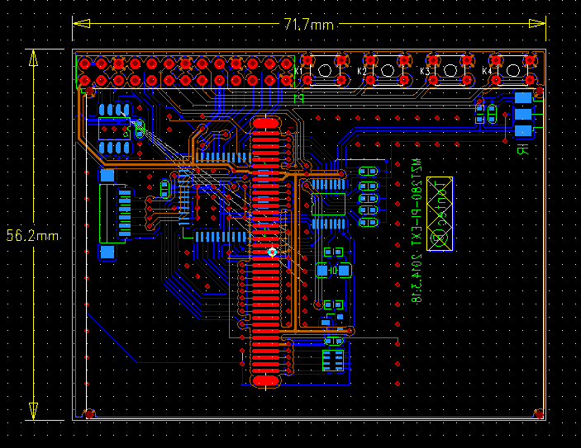

5. Quick Start

For first time use，follow the instructions below：
1 Put the driver zip file（mzt280-pi-ext.rar）copy to your SD memory card using a memory card reader or transfer the zip file to your raspberry pi directly by using the SSH, and then unzip the file under the /home/pi directory。

2 Configure the config.txt file
Go into the ‘boot’ file content，and by using the ‘nano’ tool to configure config.txt, input the commends below：
sudo nano config.txt
and then find the lines:
# uncomment to force a console size. By default it will be display's size minus
# overscan.
Change
#framebuffer_width=1280
#framebuffer_height=720
to：
framebuffer_width=640
framebuffer_height=480

3 Go into the unzipped file directory，entre commend：cd /home/pi/mzt280-pi-ext/src
To edit：enter commend：make

4 Copy the ’lcd’, automated start file under the directory, to ‘/etc/init.d’ directory. Entre commend：
‘sudo cp lcd /etc/init.d’

5 To set the default display driver upon start，go into ‘/etc/init.d’，entre commend：
sudo update-rc.d lcd defaults

6 To reboot，enter commend：
sudo reboot

6.Tips:
If you can use “sudo reboot” to restart your pi ,” “sudo shutdown now” to shut down your pi, Copy rb-pi and st-pi to /sbin ,then you can use “sudo rb-pi” to restart your pi,and “ sudo st-pi” to shut down your pi

